Prediction of stock with on-go billing-cart using IOT

*Ramesh Banoth1*, G. Bhanu2, N. shirisha 2, and M. vaishnavi2*

1Department of AIMLE, GRIET, Hyderabad, Telangana, India

2UG Student, Department of AIMLE, GRIET, Hyderabad, Telangana, India

**Abstract.** Modern technology has significantly improved the quality of life for humans. However, with the increase in technology usage, there has been a rise in the number of people visiting shopping malls. As a result, the billing process has become more time-consuming, and customers often have to wait in long queues to get their goods billed. To address this issue, we propose the development of a smart shopping cart system that uses RFID and Arduino to keep track of purchased products and generate bills automatically. The main objective of this project is to reduce the time consumed in the billing process. Our On-go billing Cart with an Automatic Billing System will use an EM-18 RFID Module and Arduino.

**KEYWORDS**: RFID tags, EM-18 Reader, Arduino, LCD display, On-go billing, Stock prediction, IoT.



* Corresponding author: [:ramesh1702@grietcollege.com](mailto:ramesh1702@grietcollege.com)

**1 Introduction**

The Internet of Things (IoT) refers to devices that have sensors, processing ability, software, and other technologies that enable them to connect and exchange data with other devices and systems over the Internet or other communication networks. IoT is an interdisciplinary field that encompasses electronics, communication, and computer science engineering. It is worth noting that the term "Internet of Things" is somewhat misleading as devices do not necessarily need to be connected to the public internet. Rather, they simply need to be connected to a network and have an individual address. The Internet of Things (IoT) is a rapidly evolving field that has been made possible by the convergence of multiple technologies, such as ubiquitous computing, commodity sensors, powerful embedded systems, and machine learning. Various fields like embedded systems, wireless sensor networks, control systems, and automation, including home and building automation, have contributed to the development of IoT. In the consumer market, IoT technology is primarily associated with smart home products, such as lighting fixtures, thermostats, home security systems, cameras, and other home appliances, that support one or more common ecosystems. These devices can be controlled through devices associated with that ecosystem, such as smartphones and smart speakers.

**2 Existing approaches**

Poorvitha H R and Pavithra T N [1] presented a new smart trolley for Object Recognition and following image-based procedure developed with low cost, and low power consumption so customers can enjoy shopping without pushing shopping trolleys themselves. Using a Pi camera and IR sensors on the trolley which can detect and track the customer/human and follow the human at some limited distance.

Mrudul Padole, Apurva Gupta and Ayush Kumar [2] aimed to design an electronic smart cart device that encompasses an OLED display, an Arduino Mega 2560 board, a specially designed PCB, a Wi-Fi module, a 13.56 MHz HF RFID reader, a power supply, and a shopping cart. A novel, image-processing-based unstaffed retail shop scheme has been proposed in this paper.

Muhammad Atif Sarwar, Yousef-Awwad Daraghmi and Kuan-Wen Liu [4] designed a Self-checkout systems.They proposed a smart shopping cart with self-checkout, called ICart. ICart uses mobile cloud computing and deep learning cloud services. The Linux-based cloud server contains the yolov2 deep learning network, which identifies and adds items to the shopping list. ICart is a lightweight system made of low-cost solutions, which makes it suitable for small-scale retail stores. With ICart, customers can enjoy a seamless checkout experience and just walk out of the store without waiting in queues.

Automatic Billing System will use an EM-18 RFID Module and Arduino. Each product in the store will have an RFID tag, and every cart will have an RFID Reader. Minimising Overstock and Stockouts and dealing with Supplier unpredictability and Workflow Automation and Data Consolidation.

**3 Proposed method**

**3.1 Problem statement**

Shopping can be a time-consuming and frustrating experience, especially if you have to wait in long queues at payment counters. The traditional billing process is outdated and inefficient, leading to errors and hindering the overall shopping experience. To overcome these challenges, a smart shopping cart with an automatic billing system can be a game-changer. This solution aims to reduce waiting times, eliminate errors, and enhance customer satisfaction, providing a smooth and seamless checkout experience for shoppers in various retail environments. By leveraging AI demand forecasting, purchasing managers can optimise their inventory levels, reduce costs, and improve customer satisfaction. This technology can help retailers stay ahead of the competition by providing a more efficient and customer-friendly shopping experience.

**3.2 Objectives**

* Minimising Overstock and Stockouts
* Dealing With Supplier Unpredictability
* Workflow Automation and Data Consolidation

**3.3 Architecture diagram**

These illustrate the overall structure of a system, showcasing major components, their interactions, and the flow of data. Architectural diagrams serve as visual blueprints, fostering communication and shared understanding among project stakeholders. They guide development efforts, facilitate discussions, and provide a visual reference for informed decision-making during the software development or system implementation process.

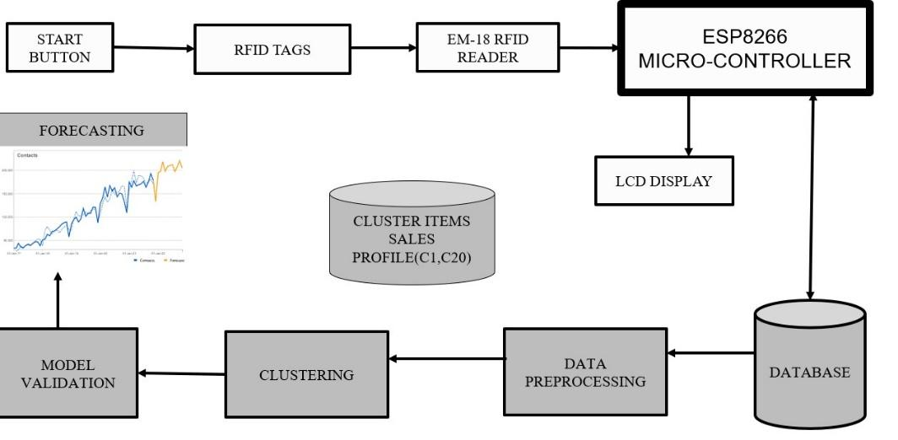

**Fig. 1.** Architecture Diagram

**3.4 Modules and its description**

3.4.1 Module 1: Detecting Phase-

Attach RFID Tags to Products:

Affix RFID tags to each product or item that the smart trolley will carry. Ensure that each RFID tag is unique, enabling individual identification.

Install an RFID reader on the On-go billing Cart. This reader can be a handheld device or integrated into the trolley structure. Connect the RFID reader to the Cart's central processing unit or microcontroller.

As items are placed in or removed from the trolley, the EM18 RFID reader scans the RFID tags. Capture the unique identification information from each RFID tag.

Maintain a database or cloud-based system that associates each RFID tag with specific products.Update the database in real-time as items are added or removed.

Implement a phase detection algorithm in the trolley's software.Analyze the RFID data to determine the current phase, such as empty, partially filled, or fully loaded.

3.4.2 Module 2: Alerting phase:

Equip the smart trolley with proximity sensors or infrared sensors.These sensors can detect the presence or absence of objects in certain compartments of the trolley.

Establish a communication system on the smart trolley, such as Wi-Fi, Bluetooth, or a dedicated IoT (Internet of Things) platform.Ensure the trolley can connect to a central server or mobile devices.Integrate the output from the proximity sensors with the trolley's central processing unit or microcontroller. Program the microcontroller to interpret sensor data.Design an interface for users to acknowledge or address alerts. This could involve buttons, touchscreens, or other input methods.

**4 Results and discussion:**

**4.1 Cart Initial State**:During the initial phase of the shopping cart, any information from the previous transaction, such as details about items, quantities, and billing, is wiped clean.

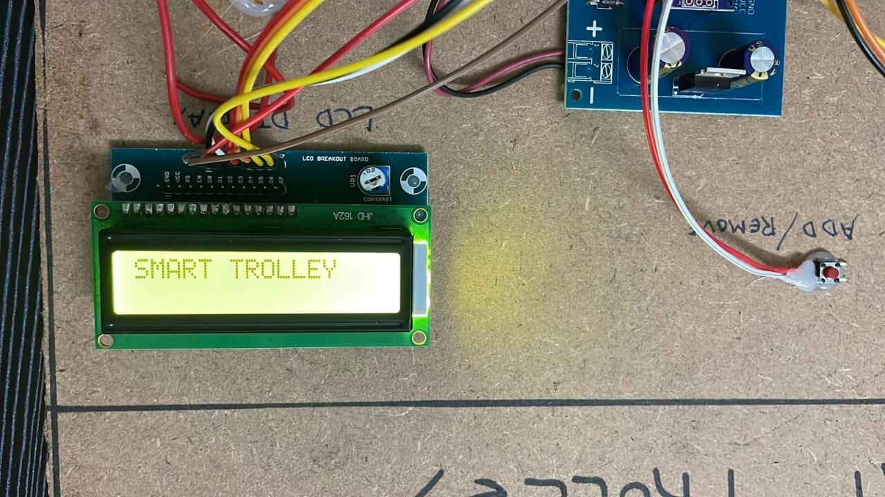

**Fig. 2. proposed kit**

**4.2 RFID TAG Reading:**

When a customer chooses a milk product and brings it close to the RFID reader for the first time, the RFID tag gets scanned. If the count is odd (like 1), the system takes this as a signal to add the milk product to the shopping cart.

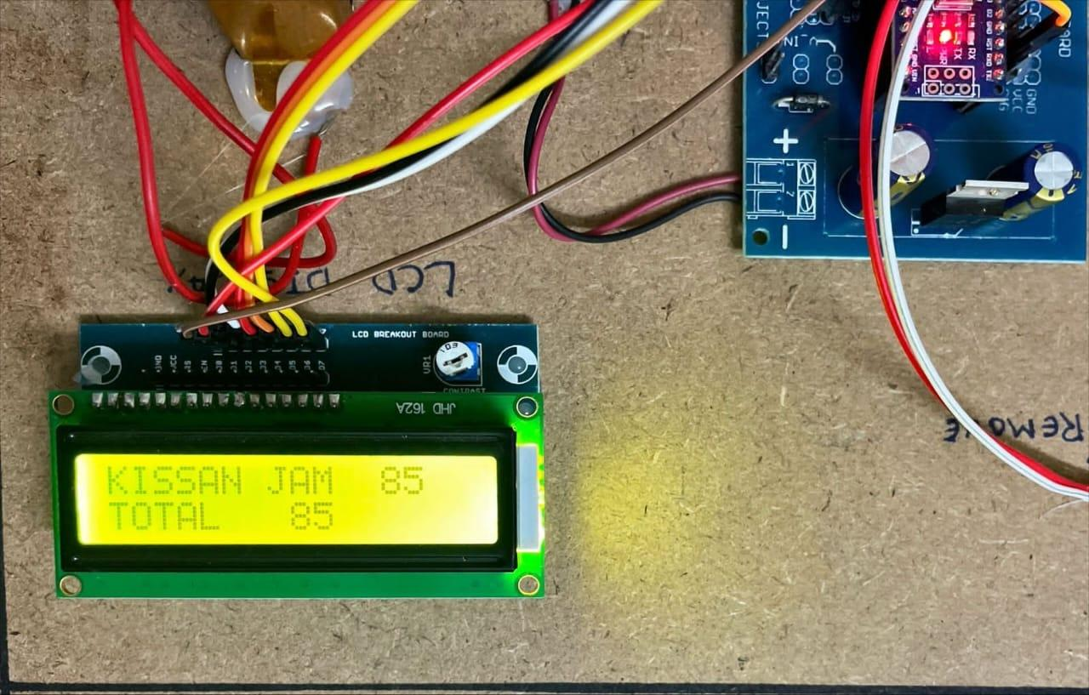

**Fig 3. product is displayed**

**4.3 Adding Items:**

As the customer brings the shampoo in close proximity to the RFID reader for the first time, the tag is successfully scanned, leading to an increment in the count, reaching an odd value (e.g., 1). The system interprets this odd count as a command to incorporate the shampoo into the shopping cart.

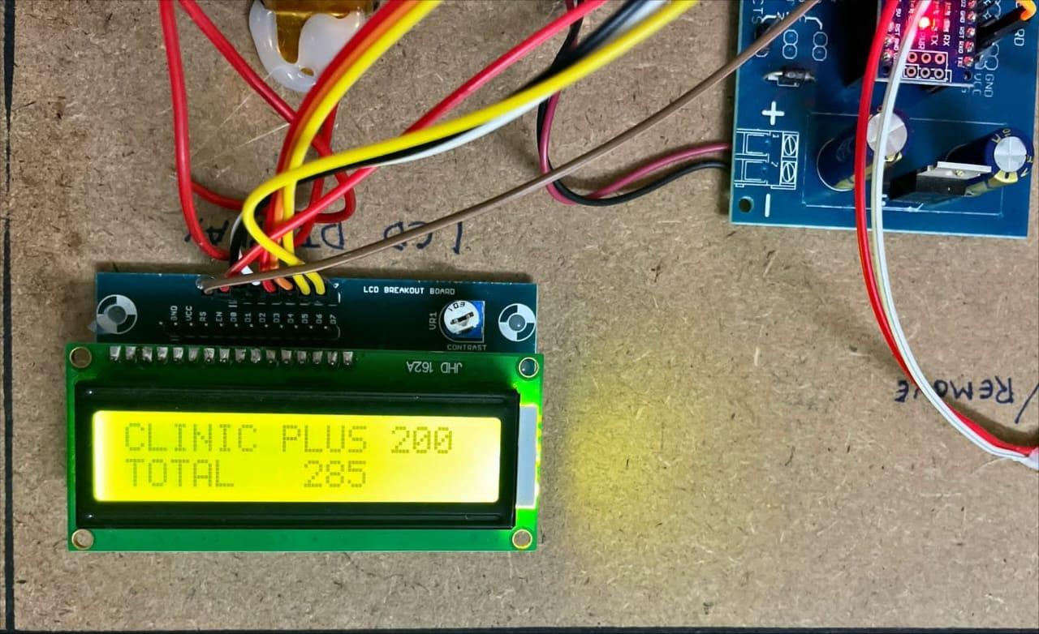

**Fig 4. price and product is displayed**

**4.4 Subtracting Items:**

Now, let's say the customer changes their mind and puts the vim back on the shelf.When the RFID tag is read again, the count becomes even (2).The system interprets this even count as an instruction to subtract the vim from the cart since the customer decided not to purchase it.

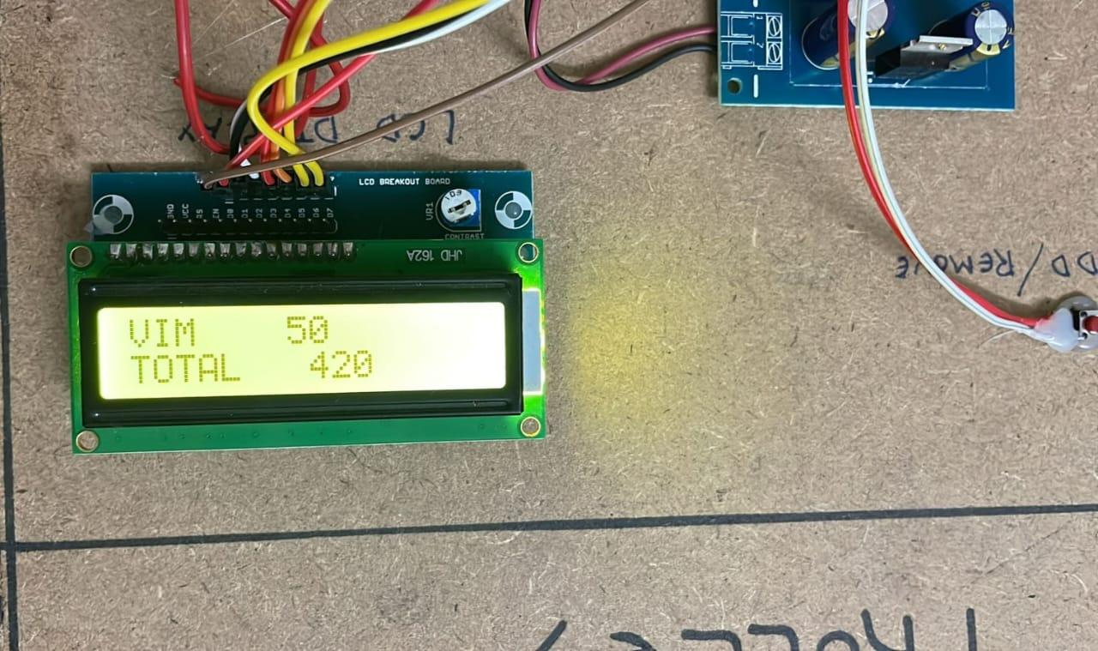

**Fig 5. Total amount is calculated**

Upon completing their shopping or desiring to review the total, the user presses the reset button. Subsequently, the system engages in the computation of the total billing amount, taking into account the prices corresponding to each item added to the cart. The outcome of this calculation is presented on an LCD screen, providing the user with a detailed overview of the total expenses before concluding the purchase.



**4.2 MACHINE LEARNING ALGORITHM**

The Walmart dataset employed for the smart shopping application encompasses a rich repository of meticulously organised information.

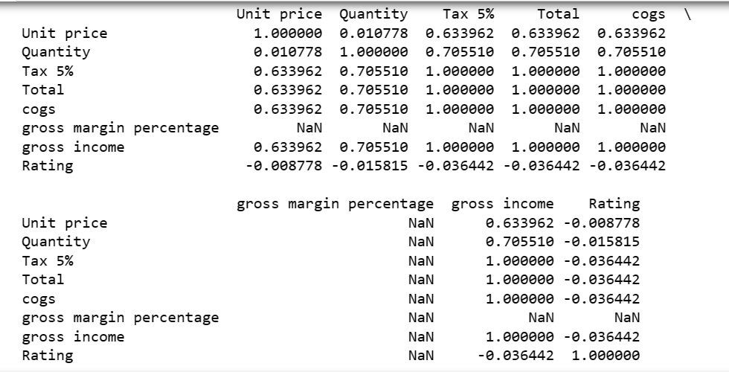

**Fig 6. machine learning algorithm used**

**4.2.1**  **Data Preprocessing :**

Data processing serves as a foundational prerequisite for deriving insightful outcomes.

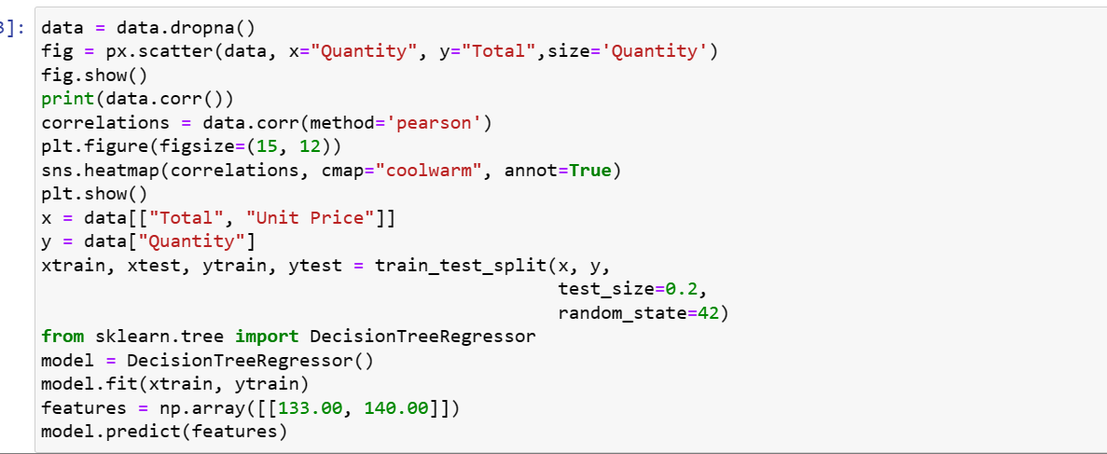

**Fig 7. python source code used**

**4.2.2 Correlated Data :**

Correlation analysis is vital for comprehending how changes in one variable may correspond to changes in another, thereby aiding in feature selection and enhancing the model's predictive capabilities.Identifying correlated data involves recognizing patterns of interdependence or mutual influence between different variables within the dataset.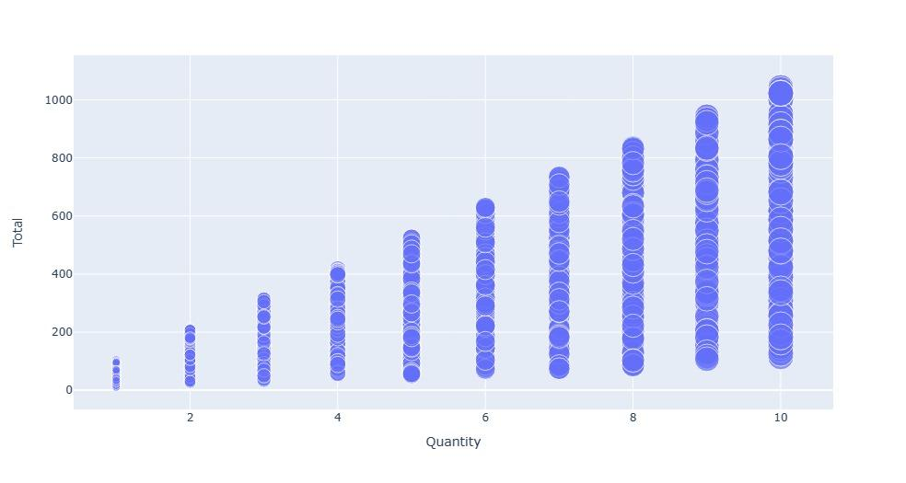

**Fig 8. Graphical representation of the products**

**4.3.3 Forecasting**

In the realm of forecasting, sophisticated algorithms play a pivotal role in leveraging historical data patterns to predict future trends or outcomes. 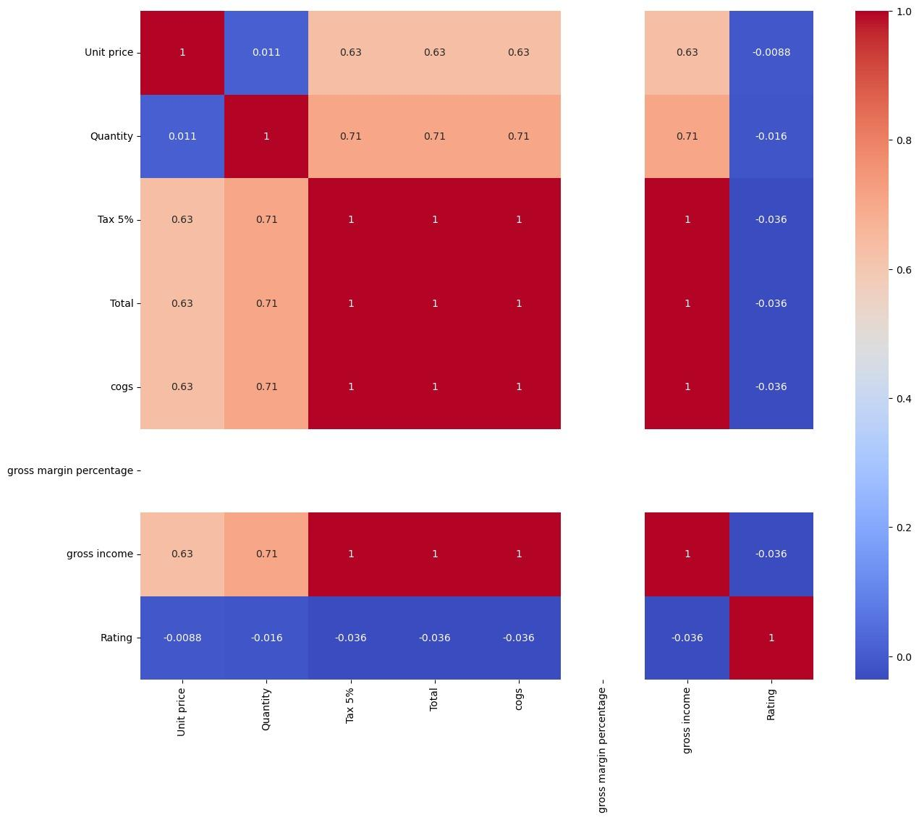

**Fig 9. Predicted forecasting**

**5 Conclusion and Future Enhancements**

**5.1 Conclusion**

The project utilised RFID technology, an EM-18 reader, and Arduino to streamline the billing process, aiming to reduce wait times in long queues and enhance inventory management efficiency. The primary objective is to provide customers with a quicker and more convenient billing experience while simplifying inventory control. This system is particularly applicable in crowded shopping malls where large volumes of customers can experience delays. In the realm of automation, this automatic billing system represents a significant technological advancement. It is poised to replace the existing barcode system, offering a more efficient and time-saving alternative. The implementation of this technology not only contributes to the ease of daily life but also plays a crucial role in advancing technology

Furthermore, the system enhances the overall shopping experience by promptly displaying the total cost of selected products to the customer. In case a product is removed from the cart, the corresponding adjustment is reflected in the bill, ensuring accuracy. Additionally, the technology paves the way for online transaction procedures during the billing process. Overall, this innovative approach is designed to make life easier, save time, and contribute to the seamless integration of technology in various aspects of daily living. The ongoing trend of online shopping, which reduces the hassle of shopping offline at stores, and introducing smart carts may not only be able to eliminate the surge but contribute to the reduction of the usage of paper bills making them environmentally friendly, & saving time wasted in standing in long queues. This also makes it more economically viable for the owner to manage fewer staff. The envisioned enhancements for the smart shopping system represent a quantum leap in the realm of user-centric retail experiences. By leveraging advanced recommendation algorithms, the system is poised to decode user preferences with unparalleled accuracy, ensuring a personalised and gratifying shopping journey.

**5.2 Future Enhancements**

Implementing sophisticated recommendation algorithms that rely on user preferences, behaviour, and historical data, coupled with the integration of natural language processing (NLP) to augment the system's capacity to comprehend and address user inquiries.

Enhancing the user profiles to include more detailed preferences and demographics and provide personalised promotions, discounts, and product suggestions based on individual preferences.

Allowing users to virtually try on clothing, and accessories, or visualise furniture in their living spaces using AR and implement AR features for in-store navigation, helping users locate products more efficiently.

Integrate voice-activated shopping capabilities to enable users to make purchases and navigate the system through voice commands.

Implementation of frictionless checkout processes, including contactless payment options and automated billing.

Connecting IoT devices to the shopping system for inventory tracking and automatic replenishment of goods and enabling smart home devices to interact with the shopping system, such as adding items to a shopping list through voice commands.

**References**

1. Mr Manikandan and Mr Mohan “RFID Based Shopping Trolley for Supermarkets”, JCHPS,8 June (2017).
2. Mr S. Balamurugan and Mr S. Balaji “Smart Shopping Cart”, International Conference on Microelectronic Devices, Circuits and Systems (ICMDCS) 10-12 August (2017).
3. Mr Kumar and Mr Gupta. A “Smart Trolley using Arduino”, International Journal of Advanced Research in Computer Engineering & Technology (IJARCET),12 December (2013).
4. R.O’ Neil “Smart trolley for shopping malls”. European Journal of Molecular & Clinical Medicine, November (2020).
5. Mr Inamdar, Mr Singh “Smart cart using automatic billing, product information, product recommendation using RFID,(2015).
6. Mr P. Chandrasekar and Ms T. Sangeetha “Smart shopping cart with automatic billing system through RFID and transmitter and receiver”, IEEE, (2014).
7. Leena Thomas, Renu Mary George “Smart Trolley with Advanced Billing System” International Journal of Advanced Research in Electrical, 3, March (2017).
8. A. Yewatkar, F. Inamdar, R. Singh, Ayushya, and A. Bandal, “Smart Cart with Automatic Billing, Advances in Computing, Communications, and Informatics (ICACCI), pp. 2346-2352, (2016).
9. Suraj.S, Vishal Guruprasad, Udayagiri R Pranava, Preetham S Nag, “RFID Based Wireless Intelligent Cart Using ARM7,” International Journal of Innovative Research in Science, Engineering and Technology, Vol. 5, Issue 8, (2016).
10. Suryaprasad J, Praveen Kumar B O, Roopa D & Arjun A K, “ A Novel Low-Cost Intelligent Shopping Cart,” IEEE,(2014).
11. Komal Ambekar, Vinayak Dhole, Supriya Sharma,“Smart Shopping Trolley Using RFID,” International Journal of Advanced Research in Computer Engineering & Technology (IJARCET), Volume 4 Issue 10, (2015).
12. K.Gogila Devi, T.A.Kaarthik, N.Kalai Selvi, K.Nandhini, S.Priya, “Smart Shopping Trolley Using RFID Based on IoT,” International Journal of Innovative Research in Computer and Communication Engineering. Vol. 5, Issue 3, (2017).
13. Chandrasekar. P , Ms. T. Sangeetha, “ Smart Shopping Cart with Automatic Central Billing System through RFID and ZigBee,” IEEE, (2014).
14. Galande Jayshree, Rutuja Gholap, Preeti Yadav, “ RFID Based Automatic Billing Trolley,” International Journal of Emerging Technology & Advanced Engineering (2014).
15. Paxal Shah, Ms. Jasmine Jha, Nirav Khetra, Manmitsinh Zala “A Literature Review Improving Error Accuracy and Range based on RFID for Smart Shopping,” International Journal for Scientific Research & Development(IJSRD),(2015).